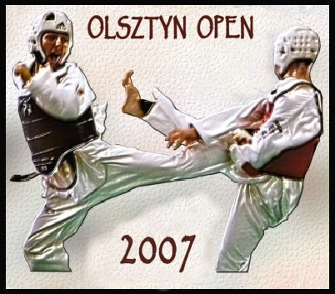
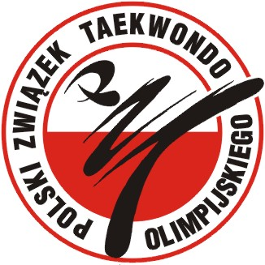
OLSZTYN OPEN 2007


PRE-QUALIFICATION TAEKWONDO OLYMPIC TEST

OLSZTYN, 01 – 02 DECEMBER 2007

Promoter: Polish Taekwondo Federation Organizers: Warmia-Mazuria Regional Taekwondo Federation & OSiR Olsztyn

Organizers office:
Olsztyn Centre of Sports and Recreation
Żołnierska str. 13a 10-558 Olsztyn
tel. +48 89 527 74 02 fax. +48 89 527 45 10
E-mail: osir@osir.olsztyn.pl http://www.osir.olsztyn.pl

Place and date:
Place: Hala Widowiskowo - Sportowa “URANIA”
(“URANIA” Indoor Olsztyn Centre of Sports and Recreation)
Aleja Marszałka J. Piłsudskiego 44, 10-450 Olsztyn
Tel/fax. +4889 533 51 84

Date: Friday 30th of November, Saturday 1st and Sunday 2nd of December 2007

Schedule: Friday - 30th
- Arrival and accommodation
- 16⁰⁰ – 20⁰⁰ - weight in for seniors classes
in “Urania” Sport Center Al. M.J. Piłsudskiego 44
- 20³⁰ - Head of Teams and Coaches meeting
in “Urania” Sport Center Al. M.J. Piłsudskiego 44

Saturday - 1 ^{st} of December – Pre-Qualification Olympic Test

- 08³⁰ – 15⁰⁰ - pre-eliminary
- 15³⁰ – 17⁰⁰ - break
- 17⁰⁰ – 18⁰⁰ - weight in for youth classes
- 18⁰⁰ – 21⁰⁰ - Official Opening , Finales and Martial Arts Show

Seniors male olympic weights: -58kg, -68 kg, -80kg, +80kg
Seniors female olympic weights: 49 kg, -57kg, -67kg, +67kg

Sunday - 2nd of December – Olympic Hopes Youth Tournament

- 9⁰⁰ – 16⁰⁰ pre-eliminary and final fights

Youth weights: -30, -32, -35, -38, -41, -45, -49, -53, -57, +57 kg
(male and female separately, NO contact to the head allowed )

Entry:

Category and age: Seniors (17 years old – born in 1990 and older) – male and female
Youth (11 – 12 years old – born between 1995-1996)

Graduation: Seniors must hold at least 4nd kup,
Youth must hold at least 7th kup

Rules: WTF Rules and Polish Taekwondo Federation Regulations
Youth Tournament: no contact to the head, compulsory instep protection and head gear

Protection gear: All protector equipment (hoogoo, headgear, shin-and forearm-protectors, groin-
protector, gloves and mouth protectors) must be WTF-approved and be brought to the competition by the competitor.

Entry fee: 20 € per senior competitor
15 € per youth competitor
Taekwondo is a Full Contact Competition Sport, where injuries cannot be excluded. Neither the organizer nor the promoter of the event can be held responsible for any damages or injuries and therefore all competitors MUST have a valid insurance that will cover costs of possible injuries. All costs in connection with possible injuries or damages will be cover by competitors.

Accommodation:
Cost per night per person (breakfast included) is:
a/ Hotel “Relaks” ** - 25 € per person per night ( around the “URANIA” Indoor Sports and Recreation Center in the walking distance 300 meters) -
b/ Hotel „Żbik” *** - 35 € per person per night ( 7 km from competition place, transport included)
This special price is possible only by booking through the Organizer’s office.

Attention:
1/ Referees:
Each team can send one referee: accommodation and fee will be paid by Organizer – please let us know referee name and class within the entry form. Organizer will confirm back the referee’s participation
2/ Transportation:
Organizer can help in transportation from Warszawa airport to the sports hall and back by bus
/40€ per competitor/. For reservation, please contact organizer’s office.

Entry Form and tournament information is available at www.osir.olsztyn.pl

DEADLINE FOR ENTRIES: 16th of November 2007

