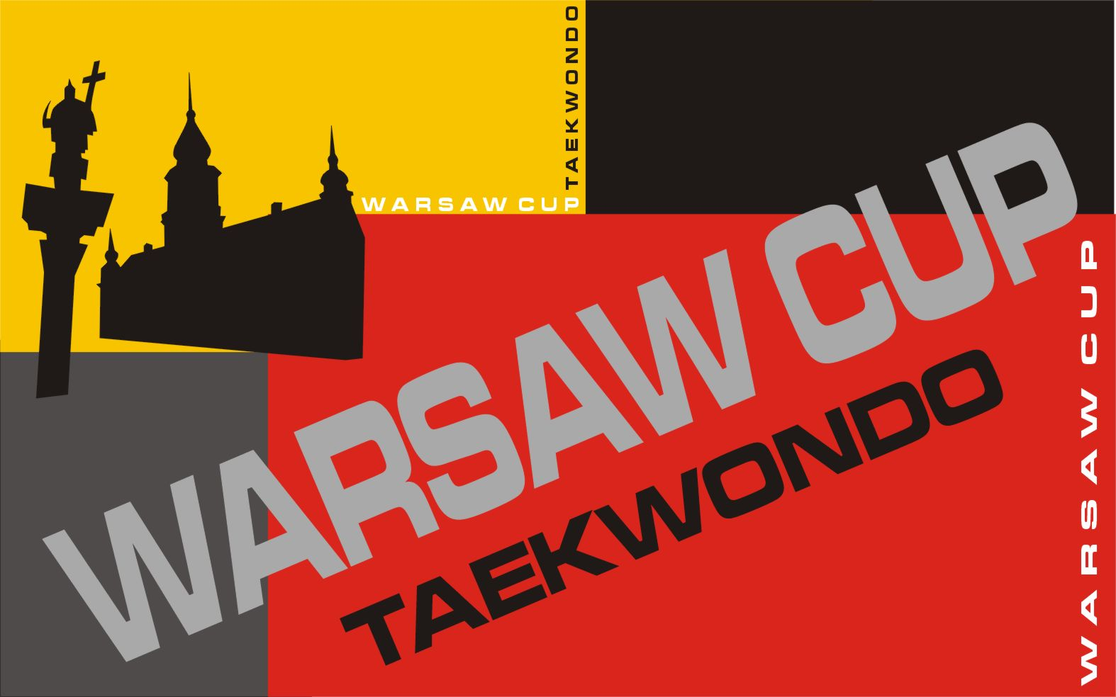

WARSAW CUP 2006
Tournament of Olympic Expectations
For juniors and seniors
year 2007 categories !

National and Regional Taekwondo Federation, Taekwondo Clubs

The Polish Taekwondo Federation WTF is pleased to invite your National and Regional, Junior Teams and clubs to participate in the

WARSAW INTERNATIONAL TAEKWONDO JUNIORAND SENIOR CHAMPIONSHIPS

The tournament will take place in Warsaw on November 24-26 2006 in the Academy of Phisical Education. We are counting on your participation in the tournament. We are certain the event will contribute to increased cooperation among federations and clubs, as well as the growth of taekwondo in Europe.

--

Yours Sincerely

Jacek Skubis

President Polish Taekwondo Federation WTF

WARSAW CUP 2006
Tournament of Olympic Expectations
For juniors and seniors
year 2007 categories !

- Date: November 24 – 26 2006 r.
- Organizer: Polish Taekwondo Federation WTF
- Host: UKS Taebaek Bielany, AZS AWF Warsaw, OZT woj. Maz.
- Function Personnel:
- PZT Board Representative Marcin Kiciński
- Organization Manager Tomasz Pyciarz
- Office Manager Michał Poniewierski

5. Place: J. Kusociński Hall Academy of Physical Education,
Marymoncka Street 34, Warsaw.

6. Tournament Office: at the event spot
November 24 3.00 p.m - 9.00 p.m
November 25 7.00 a.m - 10.00 a.m

7. Competitions rules :
Teams and contestants must hold license recognized by their own national federation. Participants must have a valid medical confirmation and grades accordnig to the ETU statute.

8. Events:
Seniors age 17 and older ( year 1989 and older ) min. 4 geup
Juniors age 13 - 16 ( year 1993 – 1990 ) min. 6 geup

Saturday 25.11
Seniors F -57 kg, 67+ kg
M -68 kg, 80+ kg
Juniors F -46 kg, -52 kg, -59 kg, -68 kg, +68 kg
M -51 kg, -59 kg, -68 kg, -78 kg, +78 kg
Sunday 26.11
Seniors F -49 kg, -67 kg
M -58 kg, -80 kg
Juniors F -42 kg, -44 kg, -49 kg, -55 kg, -63 kg
M -45 kg, -48 kg, -55 kg, -63 kg, -73 kg

- Awards: juniors and seniors

medals for places 1-3, participance certificates for all contestants, award for the best contestant, team classification places 1-5, gifts.

- Team Classification:
1 place. - 5 points, 2 place. - 3 points, 3 place. - 1 points
- Accommodation:
The student hostel ( 12 EURO ). Accommodation must be ordered directly through the Organizer’s Office together with application form. The other accommodation can be booked on your own.

- Food:
We ensure three meals at the event spot.
supper (3 EURO ), breakfast (3 EURO), dinner (5 EURO).

- Fees:
starting fee ( 10 EURO/contestant). Paid at registration.

- Entry:
The entry and the accommodation and food book in are made only on the included entry form on www.taekwondo.home.pl or www.taekwondo-bielany.anv.pl and must be send via e-mail to the final date November 15 to : zgloszenia-zawody@taekwodno.home.pl

- Other:
Teams are obliged to insure their contestants. The organizer does not take the responsibility for any accidents and the consequences of not having said insurance. According to PZT WTF and ETU regulations the organizer has the right to change given categories depending on actual calls.

- Timetable:
Friday November 24
5.00 pm - 8.00 pm Registration at the competition office

Saturday November 25

7.00am – 9.00am Breakfast( at the event spot)
9.00am – 10.00am Registration and weight at the competition office
10.30am Technical and jury meeting, drawing
11.00am Start of the competition
6.00pm Opening ceremony, semifinals, finals, shows
8.00pm - 9.30pm The contest continues

Sunday November 26

7.00am – 9.00am Breakfast ( at the event spot )
8.30am – 6.00pm Qualification and semi final fights senior/junior
6.00pm Closing ceremony

- Additional info:

POLISH TAEKWONDO FEDERATION
00–707 Warszawa
ul. Ku Wiśle 7
Tel. 0 22 840 45 57
Fax. 0 22 840 49 17
email: taekwondo@home.pl lub biuro@taekwondo.home.pl
Tomasz Pyciarz +48600 373721

