
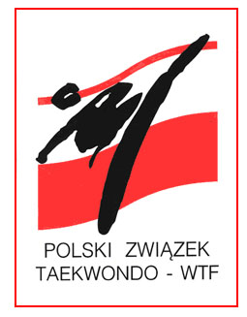
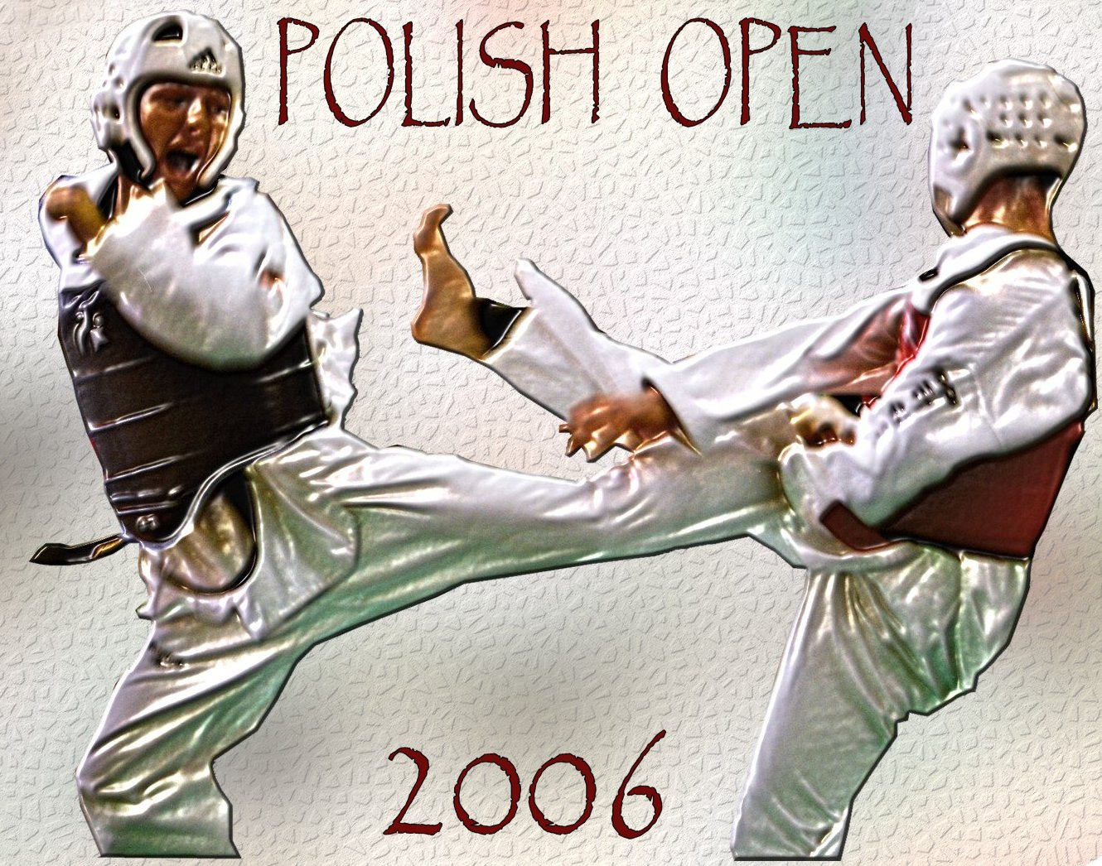
POLISH OPEN 2006

PRE – OLYMPIC TEST TOURNAMENT
OLSZTYN, 13 – 18 OCTOBER 2006

Organization

Promoter: Polski Związek Taekwondo (Polish Taekwondo Federation)
00-707 Warszawa, ul. Ku Wiśle 7, Poland
E-mail taekwondo@home.pl http://www.taekwondo.home.pl

Organizer: Ośrodek Sportu i Rekreacji
(Olsztyn Center of Sports and Recreation)
Warmińsko - Mazurska Federacja Sportu
(Warmia and Masuria Sports Federation)
Warmińsko - Mazurski Związek Taekowndo
(Warmia and Masuria Taekwondo Federation)

Tournament Director: Dariusz Nowicki

Information: Organizer’s Office
ul. Żołnierska 13a, 10-558 Olsztyn
tel. +4889 527 74 02 fax. +4889 527 45 10
E-mail osir@osir.olsztyn.pl http://www.osir.olsztyn.pl

Place and date:

Place: Hala Widowiskowo - Sportowa “URANIA”
(“URANIA” Indoor Olsztyn Center of Sports and Recreation)
Aleja Marszałka J. Piłsudskiego 44, 10-450 Olsztyn
Tel/fax. +4889 533 51 84

Date: Friday 13th, Saturday 14th and Sunday 15th of October 2006
Schedule: Friday 13th
- Arrival and accommodation
- 16⁰⁰ – 20⁰⁰ - weight for classes (only on Friday!)
in “Urania” Sport Center Al. M.J. Piłsudskiego 44
- 20³⁰ - Head of Teams and Coaches meeting
in “Hotel Nad Jeziorem Żbik”

Competition – only Olympic Weights:

Seniors male weights – -58 kg, -68 kg, -80 kg, +80 kg
Seniors female weights – -49 kg, -57 kg, -67 kg, +67 kg

Saturday 14th 10⁰⁰ – 20⁰⁰

Sunday 15th 10⁰⁰ – 16⁰⁰

Monday 16th to Wednesday 18th Joint kyorugi training sessions

Entry:

Category and age: Seniors (17 years old – born in 1989 and older) – male and female

Graduation: Seniors must hold at least 2nd kup,

Rules and weight classes: WTF Rules

Protection gear: All protector equipment (hoogoo, headgear, shin-and forearm-protectors, groin-protector and Mouth protectors) must be WTF-approved and be brought to the competition by the competitor. No protection for instep is allowed. Female groin protector is mandatory. Groin protector must be worn under the trousers. All participants have to wear the appropriate belt color according to their graduation. White dobok is mandatory. Jacket with black neck only for black belts.
Note: To use or not to use the Mouth protectors can be decided upon your own risk and decision however it’s the rule of WTF and ETU

Entry fee: 30 € per competitor
Taekwondo is a Full Contact Competition Sport, where injuries cannot be excluded. Neither the organizer nor the promoter of the event can be held responsible for any damages or injuries and therefore all competitors MUST have a valid insurance that will cover costs of possible injuries. All costs in connection with possible injuries or damages will be cover by competitors.

Accommodation:
Cost per night per person (breakfast included) is:
a/ Hotel “Relaks” ** - 25 € per person per night ( around the “URANIA” Indoor Sports and Recreation Center in the walking distance 300 meters) -
b/ Hotel „Żbik” *** - 35 € per person per night ( 7 km from competition place, transport insure)
This special price is possible only by booking through the Organizer’s office.

Joint kyorugi training sessions for the teams which are interested to stay longer for practice after tournament: cost of one day of accommodation and meal is near 35 € per person per day.

Attention:
1/ Referees:
Each team can send one referee: accommodation and fee will be paid by Organizer – please let us know referee name and class within the entry form. Organizer will confirm back the referee’s participation
2/ Transportation:
Organizer can help in transportation from Warszawa airport to Olsztyn (225 km) and back by bus /40 € per
competitor/. For reservation, please contact organizer’s office

DEADLINE FOR PRELIMINARY ENTRIES: 13th of September 2006

