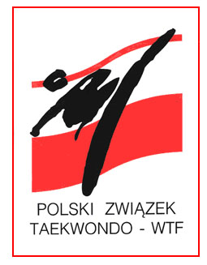
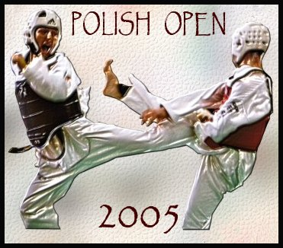
POLISH OPEN 2005

INTERNATIONAL TAEKWONDO


CHAMPIONSHIPS

OLSZTYN, 02 – 04 SEPTEMBER 2005

Organization
Promoter: Polski Związek Taekwondo (Polish Taekwondo Federation)
Organizer:
- Ośrodek Sportu i Rekreacji
(Olsztyn Center of Sports and Recreation)
- Warmińsko - Mazurska Federacja Sportu
(Warmia and Masuria Sports Federation)
- Warmińsko - Mazurski Związek Taekowndo
(Warmia and Masuria Taekwondo Federation)
Tournament Director: Dariusz Nowicki
Information: Organizer’s Office
ul. Żołnierska 13a, 10-558 Olsztyn
tel. +4889 527 74 02 fax. +4889 527 45 10
E-mail osir@osir.olsztyn.pl
http://www.osir.olsztyn.pl http://www.taekwondo.home.pl
Place and date:
Place: Hala Widowiskowo - Sportowa “URANIA”
(“URANIA” Indoor Olsztyn Center of Sports and Recreation)
Aleja Marszałka J. Piłsudskiego 44, 10-450 Olsztyn
Tel/fax. +4889 533 51 84

Date: Friday 2nd, Saturday 3rd and Sunday 4th of September 2005
Schedule: Friday 2nd
- Arrival and accommodation
- 16⁰⁰ – 20⁰⁰ - weight for classes (only on Friday!)
in “Urania” Sport Center Al. M.J. Piłsudskiego 44
- 20³⁰ - Head of Teams and Coaches meeting
in “Relaks” Hotel ul. Żołnierska 13A
Saturday 3rd
- 9⁰⁰ – 20⁰⁰ - competition
Juniors divisions – all weights WTF classes male and female
Seniors male weights – -58 kg, -67 kg, -72 kg, +84 kg
Seniors female weights – -51 kg, -59 kg, -63 kg, +72 kg
Sunday 4th
- 9⁰⁰ – 16⁰⁰ - competition
Seniors male weights: – -54 kg, -62 kg, -78 kg, -84 kg
Seniors female weights: – -47 kg, -55 kg, -67 kg, -72 kg
- 18⁰⁰ – 20⁰⁰ – Finals and Olsztyn Martial Arts Budo Gala!

Monday 5th to Wednesday 7th
Joint kyorugi training sessions

Entry:
Category and age: Seniors (+16 years old – born in 1989 and older) – male and female
Juniors (14 - 17 years old – born between 1991 and 1988) male and female
16 - 17 years old competitors can participate in one age class only: seniors or juniors

Graduation: Seniors must hold at least 2nd kup, juniors must hold at least 4th kup

Rules and weight classes: WTF Rules

Entry fee: 25 € per competitor
Accommodation:

All teams will be located in the hotels around the “URANIA” Indoor Sports and Recreation Center in the walking distance (300 – 1000 meters).
Cost per night per person (breakfast included) is:
a/ 15 €
b/ 25 €
c/ 40 €
depends on the hotel standard
This special price is possible only by booking through the Organizer’s office.

Joint kyorugi training sessions for the teams which are interested to stay longer for practice after tournament: cost of one day of accommodation and meal is near 35 € per person.

Attention:
1/ Referees:
Each team can send one referee: accommodation and fee will be paid by Organizer – please let us know referee name and class within the entry form. Organizer will confirm back the referee’s participation
2/ Transportation:
Organizer can help in transportation from Warszawa airport to Olsztyn (225 km) and back by bus. For reservation and price, please contact organizer’s office

DEADLINE FOR PRELIMINARY ENTRIES: 14th of August 2005

